C++ Recursion

A function that calls itself is known as recursive function. And, this technique is known as recursion.

## How recursion works in C++?

void recurse()

{

... .. ...

recurse();

... .. ...

}

int main()

{

... .. ...

recurse();

... .. ...

}

The figure below shows how recursion works by calling itself over and over again.

### Explanation: How this example works?

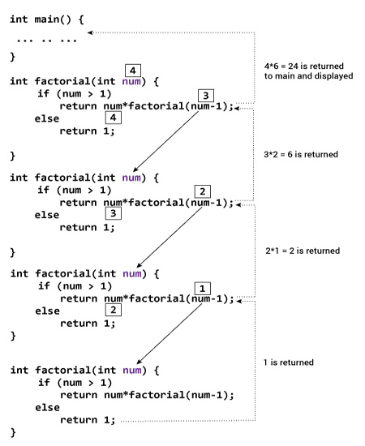

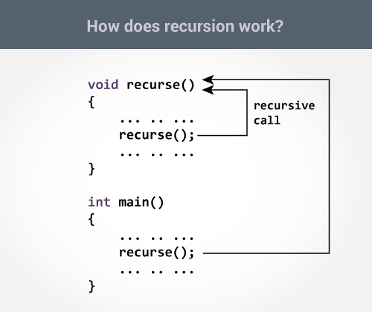

The recursion continues until some condition is met.

## Example 1: Factorial of a Number Using Recursion

// Factorial of n = 1*2*3*...*n

#include <iostream>

using namespace std;

int factorial(int);

int main()

{

int n;

cout<<"Enter a number to find factorial: ";

cin >> n;

cout << "Factorial of " << n <<" = " << factorial(n);

return 0;

}

int factorial(int n)

{

if (n > 1)

{

return n*factorial(n-1);

}

else

{

return 1;

}

}

**Output**

Enter a number to find factorial: 4

Factorial of 4 = 24